INTRODUCTION TO LUNIX

Names:Umutoniwase Benefice
ID:27368

* write the steps passed throught to download and install then push on github.

Step 1: Check your computer
Before you start, make sure:

You have Windows, macOS, or Linux

You have internet access

You have admin rights on your computer

Step 2: Go to the VirtualBox website

Open your web browser (Chrome, Edge, Safari, etc.)

Type www.virtualbox.org

Press Enter

Step 3: Download VirtualBox
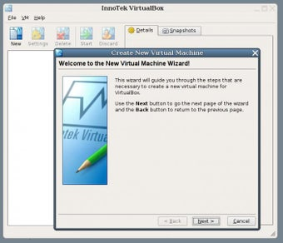
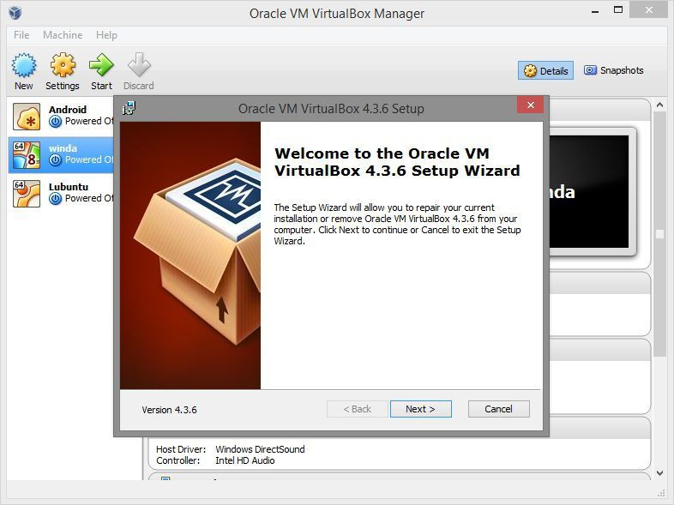


On the website, click “Downloads”

Choose the version for your operating system:

Windows hosts → for Windows

macOS hosts → for Mac

Linux distributions → for Linux

The download will start automatically

Step 4: Install VirtualBox
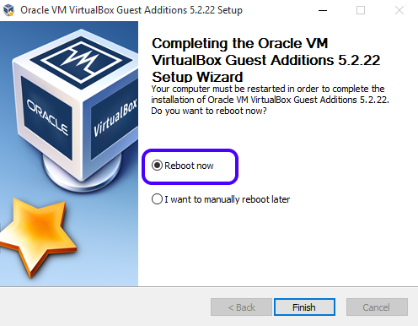
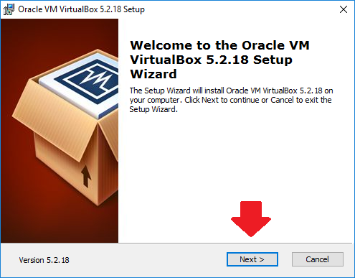

On Windows:

Open the downloaded .exe file

Click Next

Keep default settings (recommended)

Click Install

Click Finish

On macOS:

Open the downloaded .dmg file

Double-click VirtualBox.pkg

Click Continue → Install

Enter your Mac password if asked

Finish installation

Step 5: Allow permissions (important)

If your system asks for permission (security or network), click Allow / Yes

On macOS, you may need to allow Oracle in System Settings → Security

Step 6: Open VirtualBox

Open VirtualBox from your apps or start menu

If it opens, 🎉 installation is successful

Step 7 (Optional): Install Extension Pack

Go back to the Downloads page

Download VirtualBox Extension Pack

Double-click it and install
(This adds USB, webcam, and other features)

If you want, I can also:

Help you install Windows or Linux inside VirtualBox

Explain what VirtualBox is used for

Give steps in very simple exam-style points

*write the concepts you have covered in github and push on git hub

What you need first

A GitHub account

Git installed on your computer

Internet access

Step 1: Create a repository on GitHub

Go to https://github.com

Log in to your account

Click New repository

Enter:

Repository name (example: virtualbox-notes)

Description (optional)

Choose Public or Private

Click Create repository

Step 2: Create a project folder on your computer

Create a new folder (example: virtualbox-notes)

Open the folder

Create a file named README.md

Step 3: Write the concepts in README.md
Open README.md and write the concepts you covered, for example:
# VirtualBox Installation Guide
## Concepts Covered- What is VirtualBox- System requirements- Downloading VirtualBox- Installing VirtualBox on Windows/macOS- Allowing permissions- Installing Extension Pack- Verifying installation
Save the file.

Step 4: Open terminal or command prompt

Windows: Open Command Prompt or Git Bash

macOS/Linux: Open Terminal

Navigate to your folder:
cd path/to/virtualbox-notes

Step 5: Initialize Git
git init

Step 6: Add files to Git
git add .

Step 7: Commit the changes
git commit -m "Added VirtualBox installation concepts"

Step 8: Connect local project to GitHub repository
Copy the repository URL from GitHub, then run:
git remote add origin https://github.com/your-username/virtualbox-notes.git

Step 9: Push to GitHub
git branch -M main
git push -u origin main

Step 10: Verify on GitHub

Refresh your GitHub repository page

You should see README.md with your concepts 🎉

